- Event Name: | Expert talk on Role of embryo transfer technology in animal improvement
- Date: | 15-10-25
- Venue/ Mode: | IDEA lab, ADIT
- No of Participants: | 29
- Speakers Name | Dr. Chirag P Parmar
6. About Event: | An expert talk “Expert talk on Role of embryo transfer technology in animal  improvement” was organized by department of Dairy Technology, A D Patel  Institute of Technology, Anand on 15-10-25. The speaker of the event Dr. Chirag  Parmar, Assistant Professor, Kamdhenu University, provides his valuable insights  about embryo technology i.e. selection of donor, selection of recipients,  super ovulation, embryo collection and evaluation of embryos. He further focuses on  various method of embryos transfer (surgical and nonsurgical), success rate of this  method, total cost and various breeds developed by this method recently in country.  A total of 27 students of B.Tech 3rd year students and faculties of Dairy Technology  participated in the event. At the onset of event the concluding remarks and vote of  thanks was addressed by the event co-ordinator Dr. Rajeev Kumar. We express our  gratitude to Head Dairy Technology for his motivation and support from  Principal, ADIT for the conduction of event.
7.Outcome of Event: | - Elucidate the steps of embryo transfer  - Emphasize the advantages and disadvantages of embryo transfer  - Get exposure about efficacy and success rate of embryo transfer technology
8.Event Photograph (with Geotag)
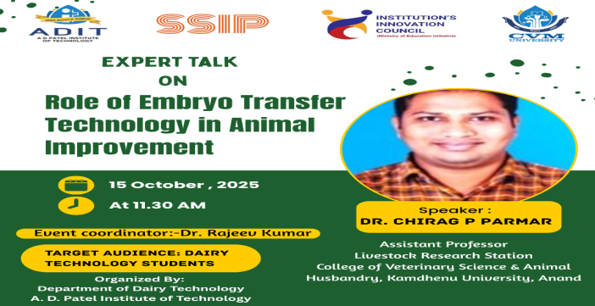 |  | 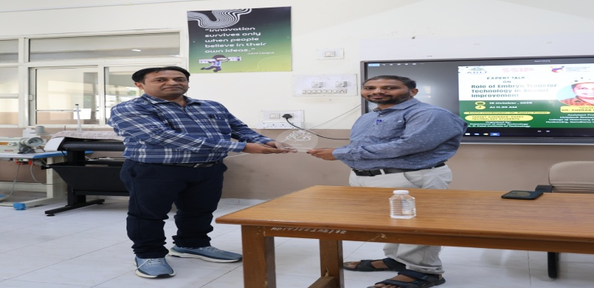
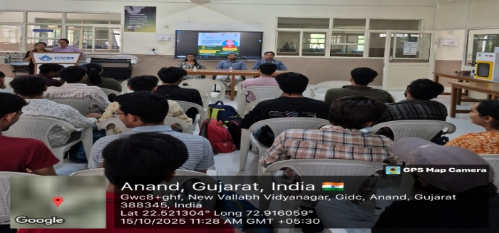 |  | 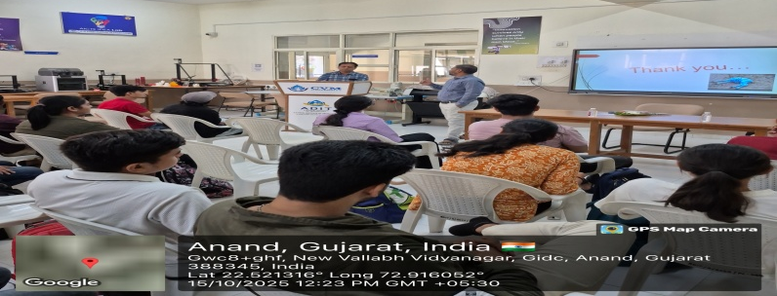
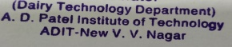
9. Signature and Stamp: 

.

